Data source links:

https://data.gov.in/resources/postal-life-insurance-pli-rural-postal-life-insurance-rpli-polices-issued-upto-2013-14

https://data.gov.in/resources/postal-life-insurance-pli-rural-postal-life-insurance-rpli-policies-issued-upto-2014-15

https://data.gov.in/resources/postal-life-insurance-pli-rural-postal-life-insurance-rpli-policies-issued-2001-02-2015-16

Infographic link:

**Source:** Open Government Data (OGD) Platform India

https://community.data.gov.in/sum-assured-under-postal-life-insurance-policies-from-2001-02-to-2014-15/

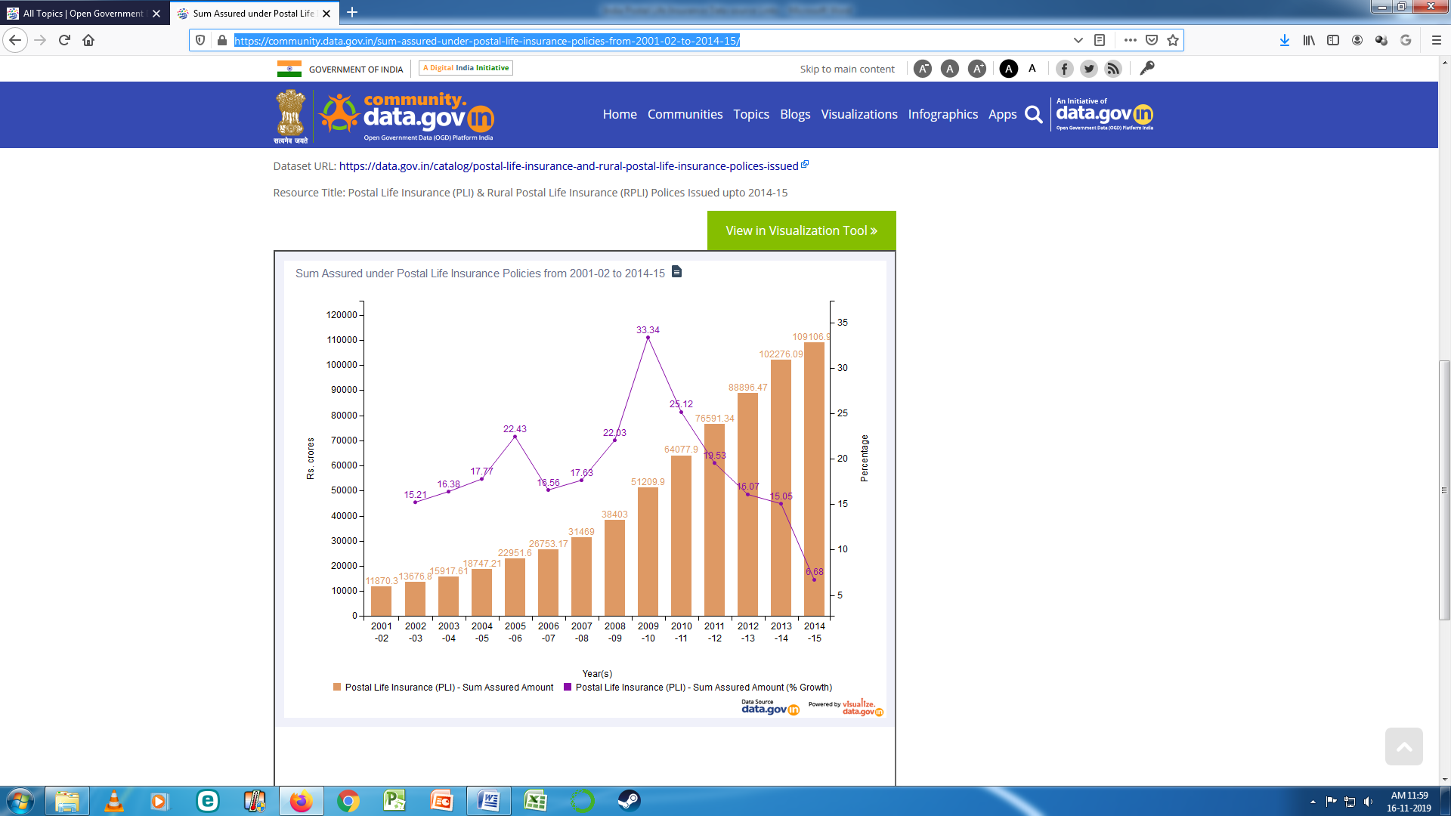

**PROJECT DESCRIPTION (for Coursera):**

" Find out the trends in the Urban Postal Life Insurances (UPLI) and the Rural Postal Life Insurances (RPLI) in India for the period between the financial years 2001-02 & 2015-16."

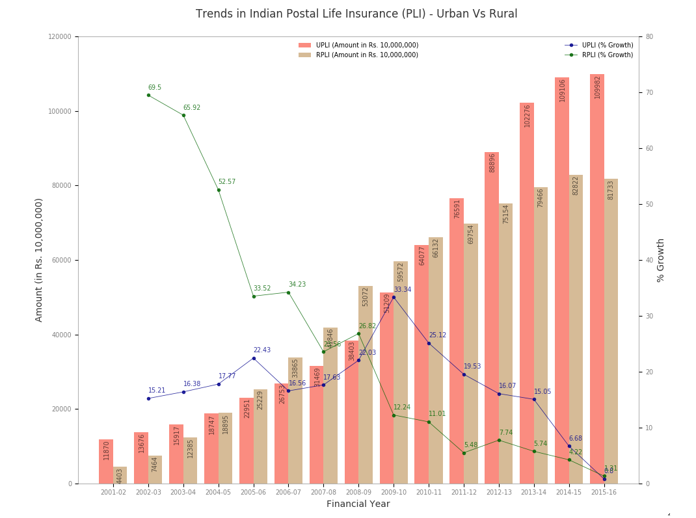

**Justification to address the research question:**

* In both Urban and Rural, though the policy amount values show an increasing trend the overall growth %s show the downward trends.
* The most affected trend is in Urban insurance compared to the Rural one.
* The Rural insurance shows an increasing trend between the financial years 2006-2010.
* Finally, both the trends hit the rock bottom in terms of % growth in the financial year 2015.

For each of the following prompts, please provide a response that links each principle to one or more elements of your visual.

* Describe your design choices for your visual in regards to Cairo's principle of **truthfulness**.
* Describe your design choices for your visual in regards to Cairo's principle of **beauty**.
* Describe your design choices for your visual in regards to Cairo's principle of **functionality**.
* Describe your design choices for your visual in regards to Cairo's principle of **insightfulness**.

**Truthfulness:**

During the Data Preparation step, picked-up the relevant data without manipulating any of them and used them as they were. The datasets contained more data (such as number of policies, corpus amount, etc.) but they were not relevant for this project.

**Beauty:**

Pleasing visual has been created with vivid colours, title, legends, labels, etc.

**Functionality:**

Two graphs (Bar charts and Line charts) used to clearly show the trends in Amounts and % Growths for Urban and Rural Postal Life Insurance data.

**Insightfulness:**

The data values are represented in each of the graphs (both bar charts and line charts) to get the insightfulness into the whole visualization.